Adding iPad to system Setup Guide:
- When “Crestron Go Tablet” App is opened, the following screen should appear:
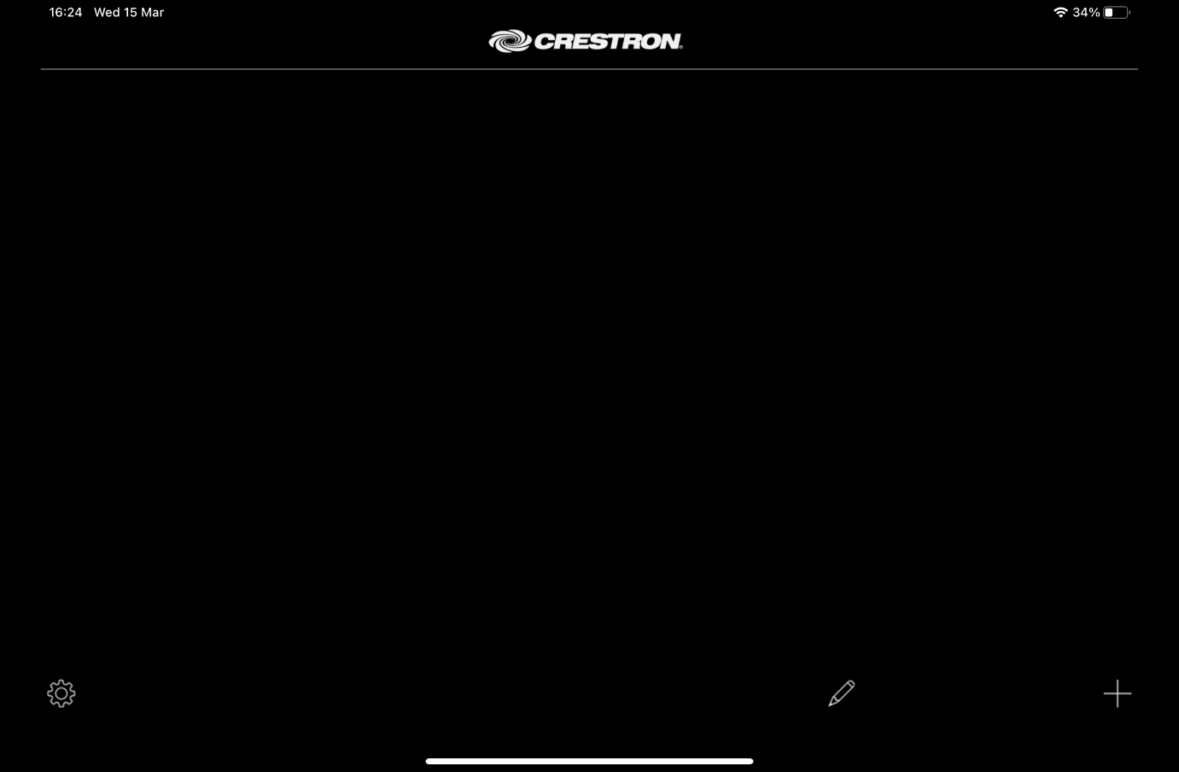
- To add a new entry, press the “+” button, this should bring up the following screen:
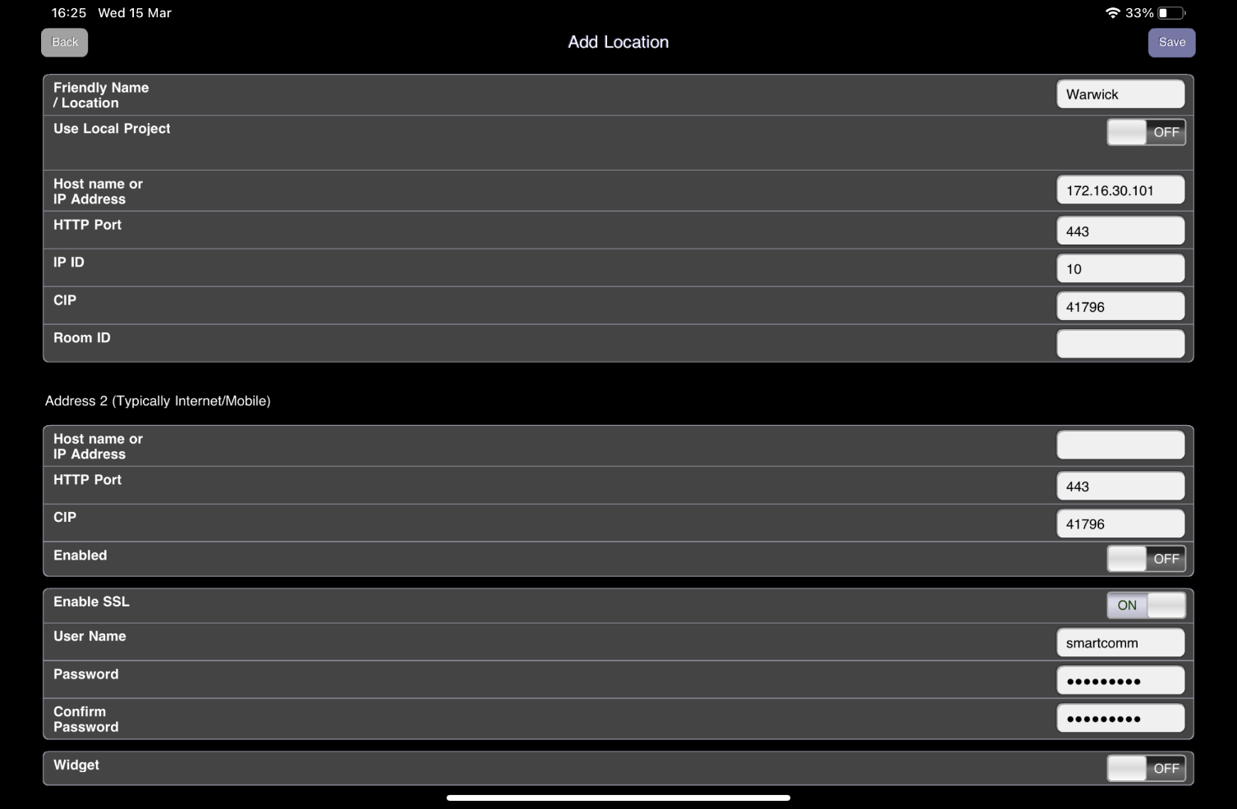
- Fill out all fields with following data:
  - Friendly Name: “Warwick”
  - Use Local Project: Toggle to “OFF”
  - Host Name or IP: 172.16.30.101
  - HTTP Port: 443
  - IP ID: 10
  - CIP: 41796
  - Enable SSL: Toggle to “ON”
  - User Name: Smartcomm
  - Password: 5m@rtc0mm
  - Confirm Password: 5m@rtc0mm

- Hit “Save” button (top right) and you should now see your entry:
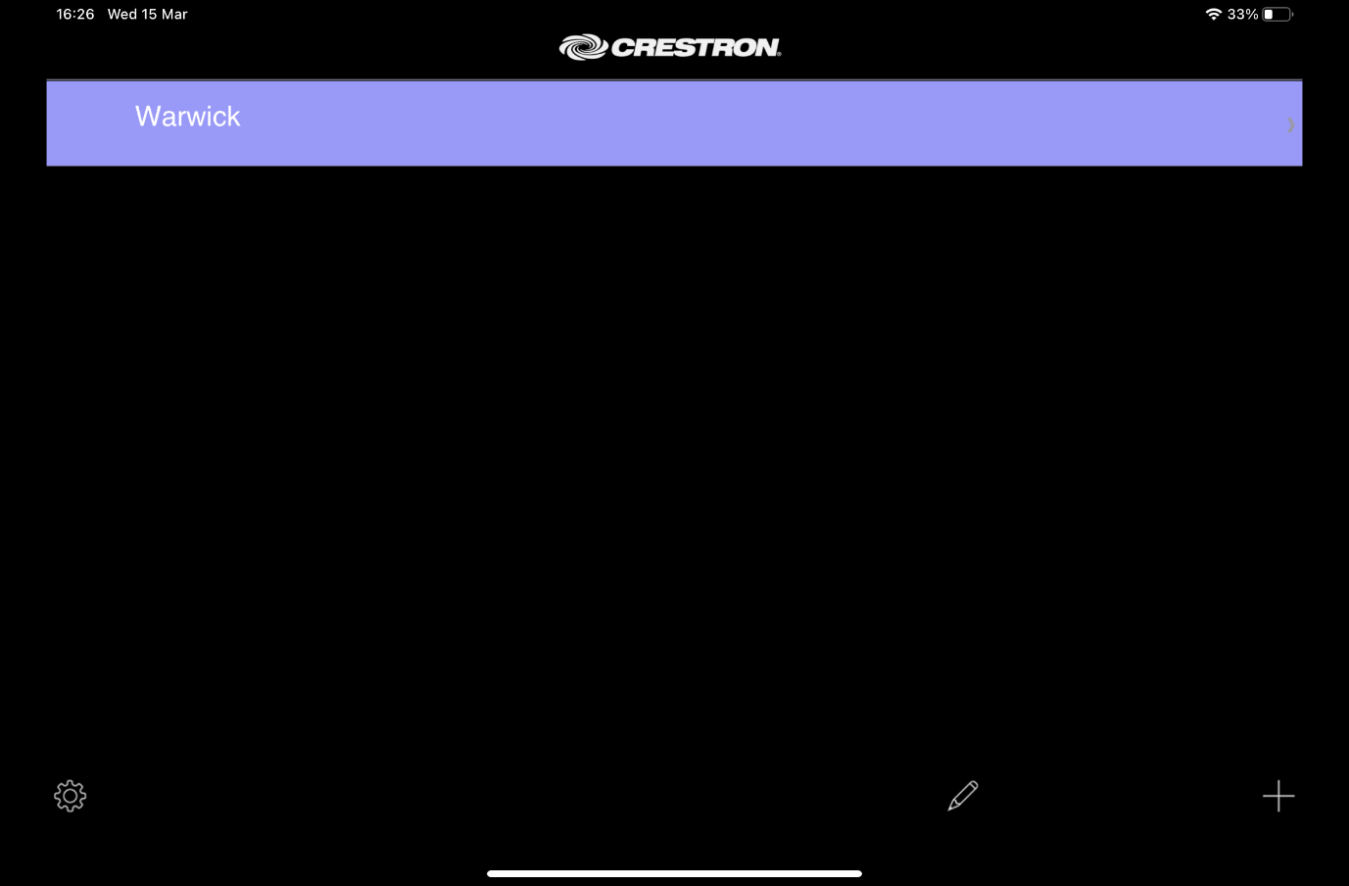
- Press the entry to connect to the system

